**Citizen AI Intelligent Citizen Engagement Platform**

1. **Introduction**

• **Project title** : Citizen AI Platform

• **Team member** : P.Thirumurugan

• **Team member** : P.Sriram

• **Team membe**r : M.Tivan Shanth

• **Team membe**r :S.Varun

1. **Project overview**

• **Purpose:**

• To build a Generative AI-based Citizen Engagement assistant using IBM Granite, This AI assistant for urban safety insights and civic engagement, helping citizens stay informed and enabling governments to provide accessible, AI-driven public support.

• **Fearture:**

1. City Analysis

Accepts a city name as input.

Generates a detailed AI-based analysis including:

Crime index and safety statistics.

Accident rates and traffic safety data.

Overall safety and livability assessment.

Provides results in a clear text format for quick understanding.

2. Citizen Services Assistant

Accepts citizen queries related to public services, policies, or civic issues.

Responds with helpful, government-style answers, making information more accessible.

Covers multiple topics such as health services, transport, education policies, etc.

3. AI-Powered Responses

Uses the IBM Granite language model to generate accurate and human-like responses.

Supports context-aware answers instead of static information.

4. User-Friendly Interface

Built with Gradio, offering a simple web-based interface.

Organized into two tabs:

City Analysis

Citizen Services

Easy input fields and clickable buttons for smooth user interaction.

5. Cross-Platform Support

Can run on CPU or GPU depending on availability.

Shareable web interface (share=True) so users can access it remotely.

6. Customizable & Scalable

Developers can modify prompts to adapt the system for:

City planning.

Public safety dashboards.

Digital government services.

Research and policy-making.

1. **Architecture**

1.User Interface Layer (Frontend)

Built with Gradio Blocks & Tabs.

Provides two interactive sections:

City Analysis Tab → Input city name, get safety analysis.

Citizen Services Tab → Input query, get government-style response.

Outputs are displayed in text boxes for readability.

2. Application Layer (Backend Logic)

Python Functions handle core logic:

city_analysis(city_name) → Generates structured prompt for city safety analysis.

citizen_interaction(query) → Generates prompt for government/civic queries.

generate_response(prompt) → Calls AI model, processes input, and returns response.

3. AI Model Layer

Uses IBM Granite 3.2-2B Instruct (LLM) from Hugging Face.

Tokenizer processes input text into model-ready tokens.

Causal Language Model (AutoModelForCausalLM) generates human-like responses.

Supports GPU acceleration if available (with torch_dtype=torch.float16 & device_map="auto").

1. **Setup Instructions**

1. Prerequisites

Before running the program, ensure you have:

Python 3.9+ installed.

pip (Python package manager).

A system with GPU (CUDA) for faster inference (optional, CPU also works).

Internet connection (to download the AI model from Hugging Face).

2. Install Required Packages

Open a terminal (or Google Colab cell) and run:

pip install torch transformers gradio -q

torch → Deep learning framework for running models.

transformers → Hugging Face library to load IBM

Granite model.

gradio → To create the web-based interface.

**5. Folder Structure**

app.py → Main entry point that ties everything together and launches Gradio app.

requirements.txt → Keeps track of Python dependencies.

config/ → Stores configurations like model name, max token length, temperature, etc.

models/ → Code for loading the IBM Granite model & tokenizer.

services/ → Business logic split into modules: city analysis & citizen services.

utils/ → Helper functions for building prompts and cleaning AI responses.

tests/ → Unit tests for ensuring correctness of features.

docs/ → Contains documentation (architecture, features, setup).

**6. Running the Application**

1.User Interface Layer (Frontend)

Built with Gradio Blocks & Tabs.

Provides two interactive sections:

City Analysis Tab → Input city name, get safety analysis.

Citizen Services Tab → Input query, get government-style response.

Outputs are displayed in text boxes for readability.

2. Application Layer (Backend Logic)

Python Functions handle core logic:

city_analysis(city_name) → Generates structured prompt for city safety analysis.

citizen_interaction(query) → Generates prompt for government/civic queries.

generate_response(prompt) → Calls AI model, processes input, and returns response.

1. **API Documentation**

* city_analysis(city_name: str) -> str

Description:

Generates a detailed analysis of a given city.

Parameters:

city_name (str) → Name of the city (e.g., "Mumbai", "London").

Response Structure:

Crime index & safety statistics.

Accident rates & traffic safety information.

Overall safety assessment.

* citizen_interaction(query: str) -> str

Description:

Provides AI-powered responses to citizen queries related to government services, policies, or civic issues.

Parameters:

query (str) → Citizen’s question (e.g., "How to apply for a driving license?").

Response Structure:

Clear, government-style response with actionable details.

1. **Authentication**

1. Simple Password Protection (Gradio Built-in)

Gradio provides username/password login out of the box:

2. Environment Variable Authentication

Store credentials in .env (never hardcode passwords):

3. Token-Based Authentication (for API use)

If you want API endpoints use a Bearer Token:

from fastapi import FastAPI, Header, HTTPException

4. OAuth2 / Google Login (Advanced)

If you want government/corporate style login (like Google or GitHub OAuth), you’ll need to integrate Gradio with FastAPI/Flask + OAuth.

Gradio → UI

FastAPI/Flask → Authentication middleware

Example libraries: authlib, flask_oauthlib

1. **User Interface**

* The application uses Gradio Blocks to build an interactive web-based UI.

It is divided into two main tabs:

1. City Analysis – for analyzing crime, accident, and safety data of a city.

2. Citizen Services – for answering queries about government services, policies, and civic issues.

Simple design with text inputs, buttons, and output boxes for readability.

* UI Components

gr.Markdown("# City Analysis & Citizen Services AI")

Displays the app title at the top of the interface.

Input Box:

gr.Textbox (label: Enter City Name)

Example: "Mumbai", "New York".

Analyze Button:

gr.Button("Analyze City")

Triggers the city_analysis() function.

Output Box:

gr.Textbox (label: City Analysis (Crime Index & Accidents))

Displays AI-generated city safety analysis in multi-line format.

Query Box:

gr.Textbox (label: Your Query)

Example: "How to apply for a driving license?".

Get Info Button:

gr.Button("Get Information")

Triggers the citizen_interaction() function.

Response Box:

gr.Textbox (label: Government Response)

Displays AI-powered answers to civic queries.

* User Flow

1. Select a Tab (City Analysis / Citizen Services).

2. Enter Input (City name or Query).

3. Click Button (Analyze City / Get Information).

4. View Output in the response textbox.

1. **Testing**

* Unit Testing → Test individual functions (generate_response, city_analysis, citizen_interaction).

Integration Testing → Ensure Gradio UI connects correctly with backend functions.

Error Handling Testing → Test invalid inputs (empty city names, nonsensical queries).

Performance Testing → Ensure responses are generated within acceptable time.

* Testing Tools

pytest → For unit and integration testing.

unittest → Built-in Python testing framework (alternative).

manual testing → Run app locally and test UI flows.

Enter a valid city (e.g., Mumbai) → Response generated.

Enter an invalid/empty city → Graceful error message.

Ask valid query (e.g., Driving License) → Correct response.

Ask irrelevant query (e.g., favorite color) → AI gives fallback response.

1. **screen shots**

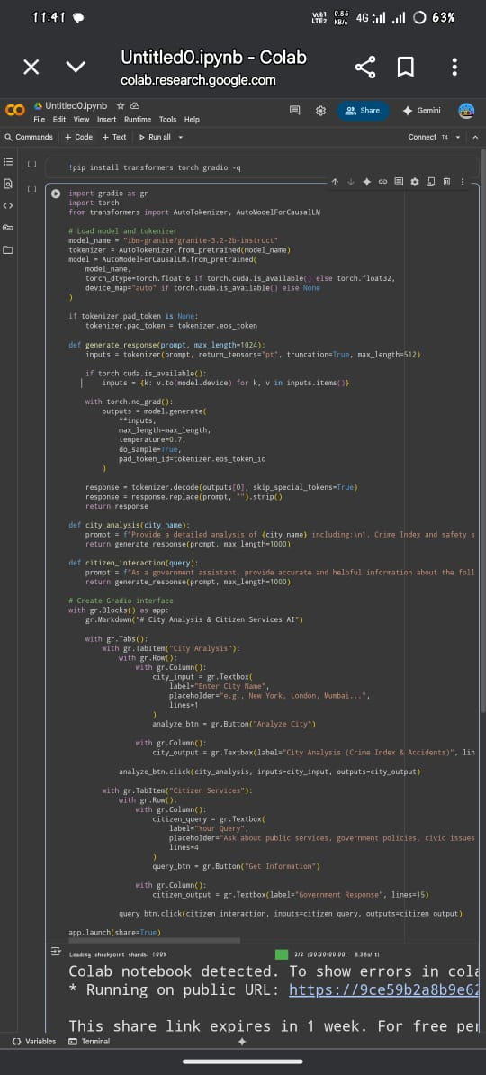**Input**

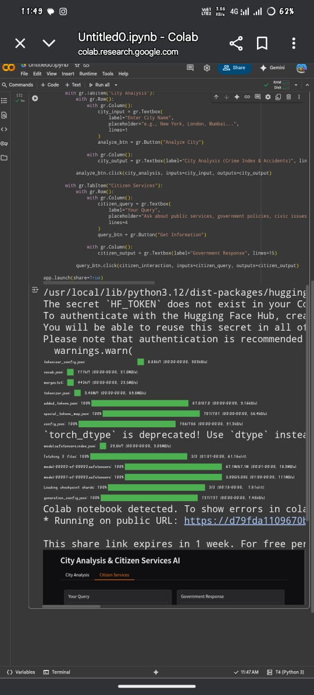

**Output**

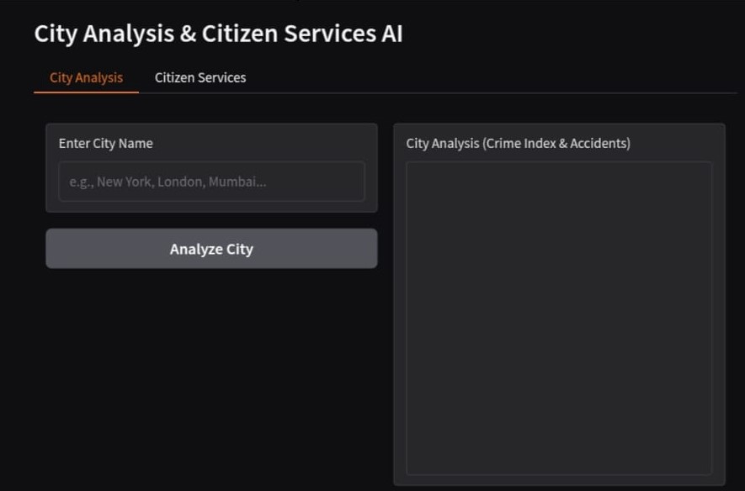

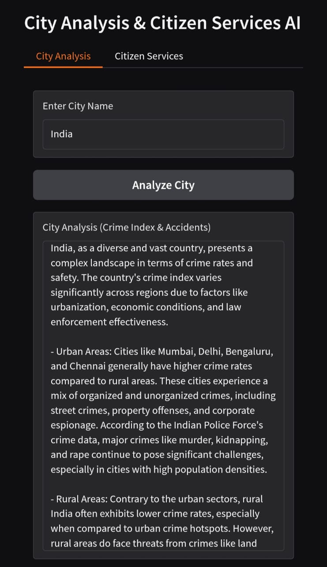

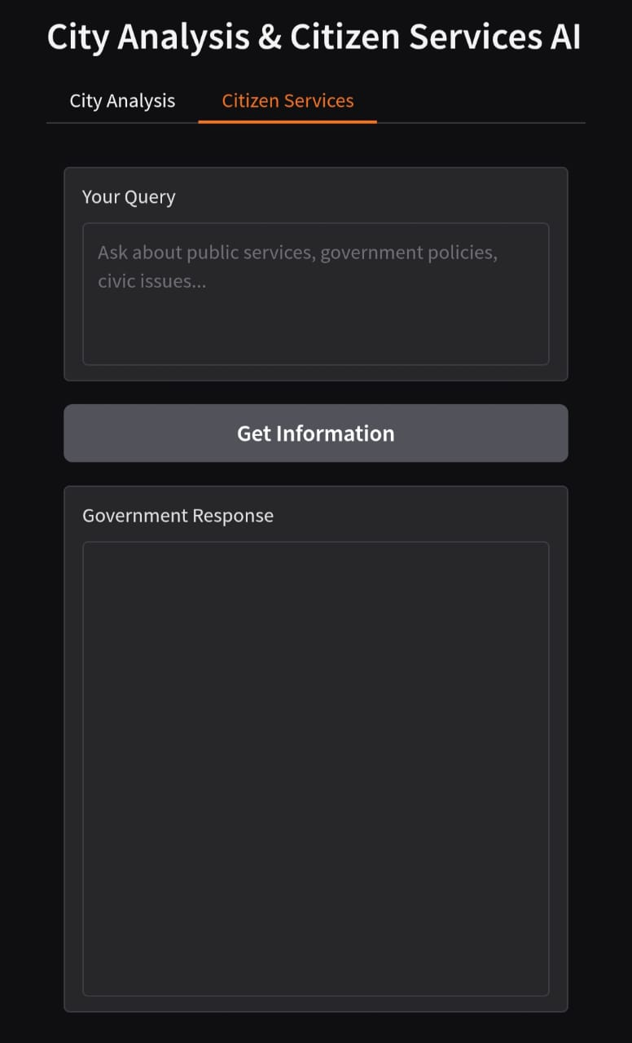

1. **Known Issues**

* AI Response Accuracy
* Performance Limitations
* Authentication Simplicity
* Input Sensitivity
* Limited Multilingual Support
* Session Dependency

1. **Future enhancement**

* Integration with Real-Time Data Sources
* Advanced Authentication & Security
* Multilingual Support
* Mobile-Friendly Interface
* Offline & Low-Resource Mode
* Improved Error Handling
* Personalized Citizen Assistance
* Dashboard & Visualization
* Scalability & Deployment
* Testing & Mocking Improvements